Year 12 Physics – Test 3 (Task 7)
Electromagnetism
Suggested Answers
Question 1
a.
Description | Marks
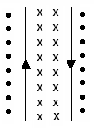 | 1

b.
Description | Marks
Wires move apart (repel) | 1

Question 2
Description | Marks
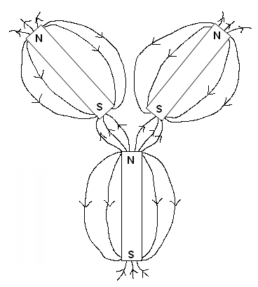  Field lines N S and do not cross  Repulsion & attraction shown correctly  Field lines leave and enter magnets perpendicular | 1  1  1

Question 3
a.
Description | Marks
F = 1/4πε_{o} q₁q₂/r²  9.00 x 10⁹ x 2.00 x 10⁻⁵ x 1.60 x 10⁻⁴/ 0.110² | 1
2.38 x 10³ N Attraction (towards each other) | 1

b.
Description | Marks
Total charge = 20.0 μC + (-160.0 μC) = -140.0 μC (1)  Net charge on each = 70.0 μC  9.00 x 10⁹ x 7.00 x 10⁻⁵ x 7.00 x 10⁻⁵/ 0.110² | 1
3.64 x 10³ N Repulsion | 1

Question 4
a
Description | Marks
$$B=\frac{μ_{o}}{2π} \frac{I}{r}$$  $$B=\frac{1.26x10-6}{2π} . \frac{2.25}{0.15}$$ | 1
3.01x10⁻⁶ T | 1

b
Description | Marks
Fc = Fe  m = Bqr/v  m = 5.5x10⁻² x 3.2x10⁻¹⁹ x 0.094 / 1.71x10⁴ | 1
9.67x10⁻²⁶kg | 1

Section 2
Question 1
a
Description | Marks
E=V/d  1.75x10³ / 0.04 | 1
4.38x10⁴ V m⁻¹ | 1

b
Description | Marks
Positive | 1
Gravity is providing the downward weight force on the drop, the drop is stationary so the electric force must be upwards | 1

c
Description | Marks
F=Eq  q = 5 x 1.6x10⁻¹⁹  8.00x10⁻¹⁹ | 1
F = 4.375x10⁴ x 8.00x10⁻¹⁹ | 1
3.50x10⁻¹⁴ N | 1

d
Description | Marks
F_{e} = mg  m= 3.50x10⁻¹⁴ / 9.8 | 1
3.57x10⁻¹⁵ kg

Question 2
a
Description | Marks
τ = nFr⊥  τ= n (BI)r⊥ | 1
25 x 9.08 x 10⁻³ x 2.2 x (2 x 0.055) x (0.5 x 0.035) | 1
9.61 x 10⁻⁴ N m | 1
NB if diameter is used and torque not doubled correct answer can be obtained. Max 1 mark

b
Description | Marks
Increasing the number of coils | 1
Increasing the strength of the permanent magnets. | 1
Increasing the current flowing through the coil | 1

c
Description | Marks
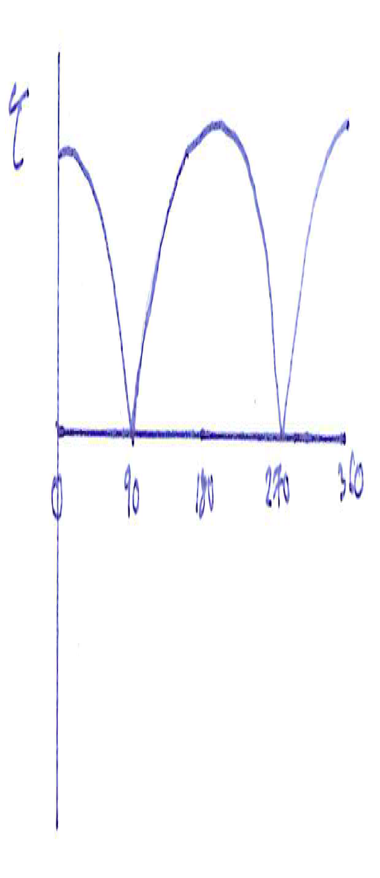  Torque shown correctly (i.e. positive and max every 180º)  Maximum torque at 0, 180, 360 | 1  1

Question 3
a
Description | Marks
Switch closed, current flows, magnetic flux from primary coil cuts the secondary coil | 1
Current is induced in the secondary coil according to Lenz’s Law and the needle deflects | 1

b
Description | Marks
As current is DC the magnetic flux cuts the coil once deflecting the needle | 1
As there is no further flux change current is no longer induced in the secondary coil | 1

c
Description | Marks
 | 1-2
emf = 0.392V | 1

Section 3
Question 1
a.
Description | Marks
Within a cycle the current flows back and to  2 x 50 Hz = 100 cycles per second1 | 1

b.
Description | Marks
$V_{RMS}=\frac{V_{max}}{\sqrt{2}}$ $120=\frac{V_{max}}{\sqrt{2}}$ so V_{max} = 120 x $\sqrt{2}$ = 169.7 V  $V_{max}=I_{max}.R$ so $I_{max}=\frac{V_{max}}{R}=\frac{169.7}{4}$ | 1
$$42.4 A$$ | 1

c.
Description | Marks
Contacts to external circuit  Slip rings  Pulley that turns coil  Axle  P  R  Q  S  PQ rotates out of page  SR rotates into page  Current  Current  S  N | 1

d.
Description | Marks
Current flows in a direction to establish a field that opposes the change in flux that created it. | 1

e.
Description | Marks
$emf= l.v.B$ for 1 length, and $v=\frac{2πr}{T}=2πrf, so emf=l.2.π.r.f.B$ | 1
There are 2 lengths each with N turns so, $emf=2.N.l.2.π.r.f.B$ | 1
The radius r is the distance from the axle to each length so  $The area of the coil A= l×2r$ , and by substitution  $$V_{max}=NAB2πf$$ | 1

f.
Description | Marks
N = 600 f = 840/60 = 14 Hz B = 0.126 T A = 0.17 x 0.09 = 0.0153 m² | 1
$V_{max}=NAB2πf$  $V_{max}=600×0.0153×0.126×2π×14$ | 1
$V_{max}$= 101.7 = 102 V | 1

